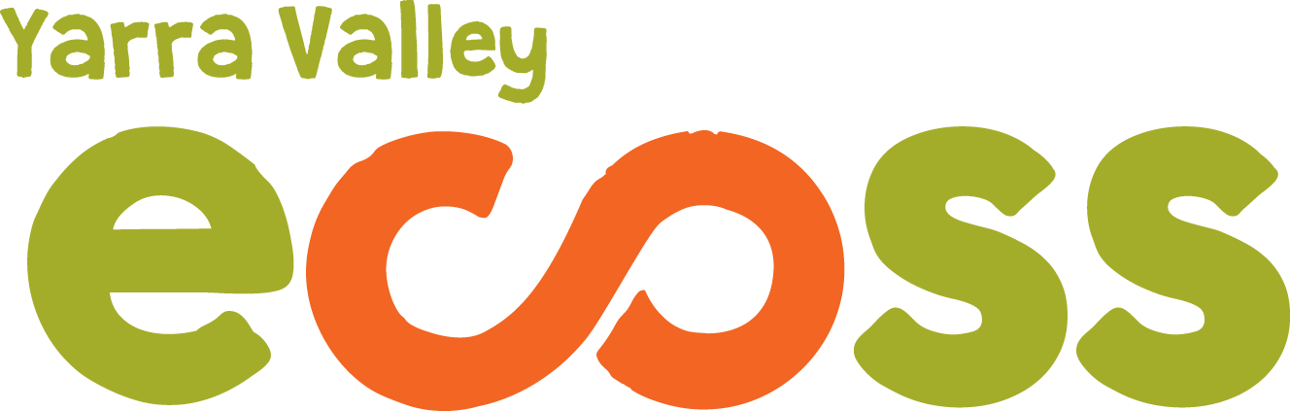

ECOTOPIA 2016 BOOKING FORM

To book a stall or demonstration time slot at the Ecotopia Junction Community Festival please complete the form below and return by email to ecotopiastalls@ecoss.org.au (or mail to: PO Box 340, Yarra Junction 3797).

Name of stall holder, presenter or organisation
Contact person
Phone number
Email
Are you not for profit? | Y / N
List products or organisations goals
How does your business contribute to ecological and / or social sustainability?
Please give brief details of your presentation if applicable
Any special requirements
Do you have insurance?  Please circle | Yes please send a copy of your certificates  No- all stall holders require insurance so the option to pay an additional fee of $5 for NFP or $10 for profit is available
Do you require power? | Y / N
Food- do you have streetrader and food handling certificates? | Y / N

PLEASE NOTE:
- Stallholders will need to provide all their own equipment such as marquees, tables etc. The Yarra Ranges Council has requested that stallholders do not use pegs as there are cables just below the ground in the area of the market.
- As part of our ‘sustainability in action’ goal we ask you to avoid using disposable packaging or receptacles or, where unavoidable, they are biodegradable. ECOSS has a wash against waste kit that may be available on the day and will determine shortly for how many stalls it will be used for.

