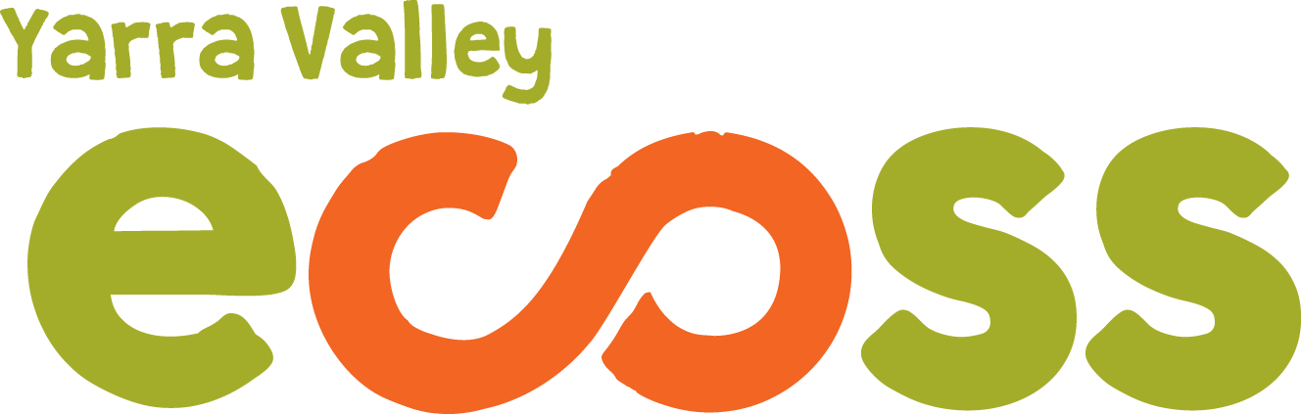

ECOTOPIA 2016 STALL HOLDER INFORMATION

Ecotopia is on again!! On Sunday April 10th 2016 Yarra Valley ECOSS will be hosting another wonderful community festival in the beautiful Yarra Ranges (Yarra Junction). Ecotopia has been enjoying increasing success and in 2015 won an award for Best Festival in the Yarra Ranges: we estimate over 1500 participants attending and thank you for your interest in being involved.
We welcome new participants and those who have been part of Ecotopia previously. This year we have leaped into some 'new' technology and decided to streamline some of our processes and so you are receiving an Automated Response in the first instance. Please have a read of the information below and if you are interested in a space at the festival please fill in the application form which you find at www.ecoss.org.au/ecotopia-date-is-set-sunday-april-10/. We thank you for you application if you have already submitted it. All inquiries will be attended to after the 15th of January when we return.
The Festival Committee would like to invite you or your group to have a stall/stand at this Community Sustainability Festival to promote your enterprise or organisation, sell your products, advertise training or exchange ideas with interested people. Stalls must be associated with the theme of sustainability in some way (in its broadest sense! Social, ecological, community etc) If there is no demonstrable way in which stall holders or their products contribute to ecological or social sustainability, we reserve the right to refuse application. Alternatively we encourage growth and change and so are more than happy to assist groups new to the ideas of sustainability to transition to more sustainable practices should you be interested.
All stall sites will be 3m X 3m and you may book and pay for more than 1 if required (at a reduced rate). There will be power available but powered sites will be limited and stallholders MUST indicate the need for power on the application form. There will be a slight change in the festival layout this year and so stall locations may differ, requests for particular stall locations will only be considered with regards to the benefit for the whole festival and only upon receipt of payment.
All stall fees are to be paid PRIOR to the festival, you will receive an invoice upon your notification of successful application and you place will only be guaranteed upon receipt of payment.

2016 fees are as follows
• $30- craft, natural products, promotion of products
• $100- food
• $180 coffee
• $15- community & environment group (NFP)
• $30- Extra for powered site to assist in the goal of being Carbon Neutral
Presenters doing free workshops or presentations at the stage may be offered free stalls but an application form must still be filled in.
PLEASE NOTE:
In difference to previous years we will be offering / confirming stall positions in rounds. This is simply for the reason that it is great for us to be able to concentrate our work efforts rather than dealing with one application at a time. We hope that the system is clear and fruitful for everybody.
Round 1 bookings will be confirmed on 26th of Jan and must be payed for by 9th Feb.
Round 2 bookings will be confirmed on 23rd Feb and must be payed for by March 8
Round 3 bookings will be confirmed on March 22 and must payed for by April 5
Information regarding bump in and out times, site map and stall location, and responses to other questions will be released in much the same time frames as the booking confirmations.
We look forward to your application and another great day!
Please direct emails and applications to ecotopiastalls@ecoss.org.au note you may well receive the same auto response however your inquiry will be attended to as soon as possible
or call Niree on 0407808852
Please note Niree is on holidays until mid January 2016 and will endeavour to answer your queries as soon as possible. If in doubt send in the application form to secure your place.

