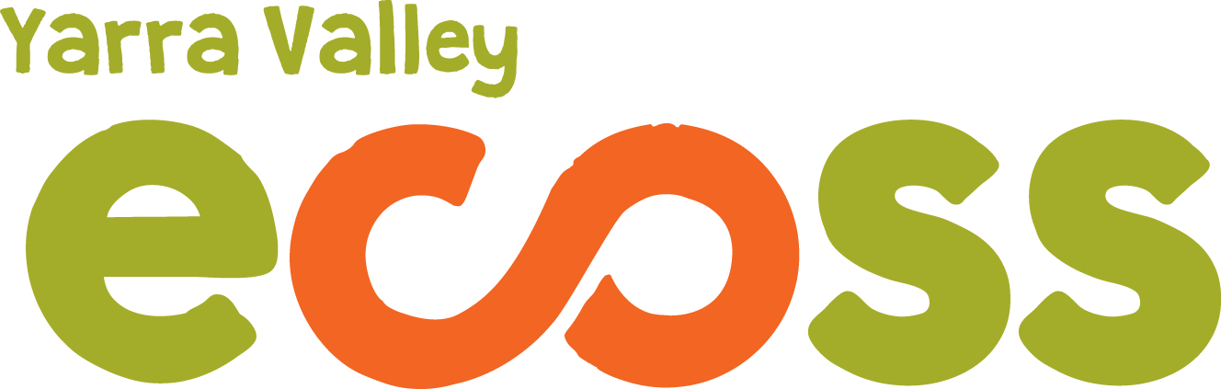

ECOTOPIA 2018 STALL HOLDER INFORMATION

Ecotopia is on again!! On Sunday March 25th 2018 Yarra Valley ECOSS will be hosting another wonderful community festival in the beautiful Yarra Ranges (Yarra Junction Parklands). This years theme is ‘Celebrating Cultural Diversity’!
We welcome new participants and those who have been part of Ecotopia previously. To enable us to streamline some of our processes you will receive an Automated Email Response in the first instance. Please have a read of the information below and if you are interested in a space at the festival please fill in the application form which you find at www.ecoss.org.au
All inquiries will be attended to after the 20th of January when we return.
Stalls must be associated with the theme of sustainability in some way (in its broadest sense! Social, ecological, community etc.) If there is no demonstrable way in which stall holders or their products contribute to ecological or social sustainability, we reserve the right to refuse application. Alternatively we encourage growth and change and are more than happy to assist groups new to the ideas of sustainability to transition to more sustainable practices should you be interested. All food and product packaging must be minimal and biodegradable. If you require any further information or recommendations about biodegradable packaging, go to: www.goinggreensolutions.com.au
All stall sites will be 3m X 3m and you may book and pay for more than 1 if required.
All stall fees are to be paid PRIOR to the festival, you will receive an invoice upon your notification of successful application and your place will only be guaranteed upon receipt of payment.

2018 fees are as follows
• $30- craft, natural products, promotion of products
• $100- food
• $150- coffee
• $15- community & environment group (NFP)
- $50- Not for profit food fee
- $50- Double stalls.
PLEASE NOTE:
We will once again be offering / confirming stall positions in rounds. This is simply for the reason that it is great for us to be able to concentrate our work efforts rather than dealing with one application at a time. We hope that the system is clear and fruitful for everybody.
Round 1 bookings will be confirmed on 30th of Jan and must be paid for by February 9th.
Round 2 bookings will be confirmed on 23rd Feb and must be paid for by March 8th.
Round 3 bookings will be confirmed on 9th March and must paid for by March 20th.
Information regarding bump in and out times, site map and stall location, and responses to other questions will be released by the 15th March.
Cancellation Policy: Any stall cancellations made after the 15th March will not be refunded.
We look forward to your application and another great day!
Please direct emails and applications to ecotopiastalls@ecoss.org.au note you may well receive the same auto response. However your inquiry will be attended to as soon as possible
or call Leanne on 0348252519.
Please note Leanne is on holidays until mid January 2018 and will endeavour to answer your queries as soon as possible. Feel free to send in your application form in the meantime.
We look forward to Celebrating Cultural Diversity with you!!!

