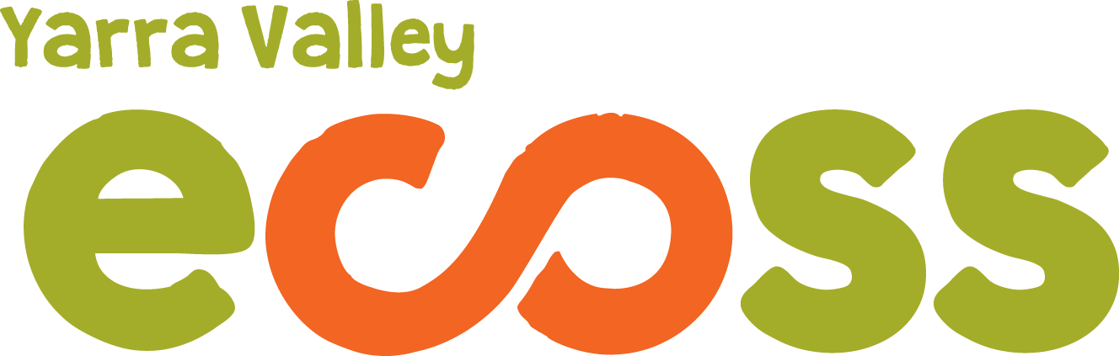

ECOSS SUN FESTIVAL 2019 BOOKING FORM

To book a stall or demonstration time slot at the ECOSS Sun Festival please complete the form below and return by email to ecotopiastalls@ecoss.org.au (or mail to: PO Box 340, Yarra Junction 3797).

Name of stall holder, presenter or organisation

Contact person

Phone number
Email

Are you not for profit?
List products or organisations goals
How does your business contribute to ecological and / or social sustainability?
Please give brief details of your presentation if applicable

Any special requirements

Do you have insurance?

Do you require power?
(Food stalls only) If yes: How many amps of power required? Eg. 10 amps.
Food-Please specify your ‘Wash Against Waste requirements’. There is the option of Bowls, Plates, Cups and Cutlery.
Food- do you have street trader and food handling certificates?

PLEASE NOTE:
- Stallholders will need to provide all their own equipment such as marquees, tables etc.
- As part of our ‘sustainability in action’ we require you to use Wash Against Waste, for all food stall holders. Please specify your needs above. Boxes of your crockery and cutlery will be at your stall site in the morning, during the day dishes will be washed and returned to your stall. We will ensure you have plenty in stock throughout the day. We thank you for your participation in reducing landfill. The compost your food stall creates will be compost for the ECOSS Community Garden.
Yarra Valley ECOSS would like to acknowledge our Wurundjeri Elders and Community Past, Present and Emerging. We acknowledge the challenges faced by Aboriginal and Torres Strait Islanders, and wish to be part of a positive change for the future.

